16.6: a) The time for the wave to travel to Caracas was 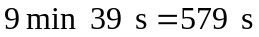 and the speed was 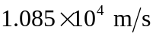 (keeping an extra figure). Similarly, the time for the wave to travel to Kevo was 680 s for a speed of 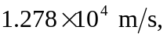 and the time to travel to Vienna was 767 s for a speed of 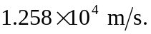 The average speed for these three measurements is 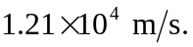 Due to variations in density, or reflections (a subject addressed in later chapters), not all waves travel in straight lines with constant speeds. b) From Eq. (16.7), 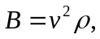 and using the given value of 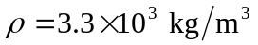 and the speeds found in part (a), the values for the bulk modulus are, respectively, These are larger, by a factor of 2 or 3, than the largest values in Table (11-1).

